Assignment Overview (for future reference)

The stack implementation was written into stack.h. A console program was written to unit test the implementation, and allow user to manually test it by adding values to the stack.
Raw C++ files are embedded below.

Instructions:
For this week's assignment, you will write your own stack using templated class in C++.
The basic outline of the class should be:
template <typename T>
class Stack {
private: std::vector<T> elements;
}
You need to add the methods for each of the following:
- push()
- pop()
- isEmpty()
Use the class in an example application.

ITE217_Week3.cpp (page 1 of 2)
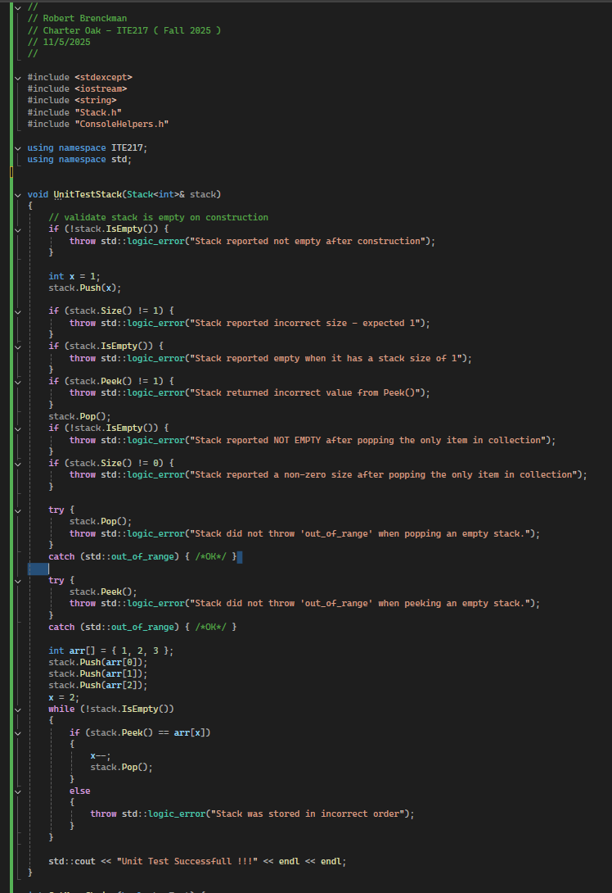

ITE217_Week3.cpp (page 2 of 2)
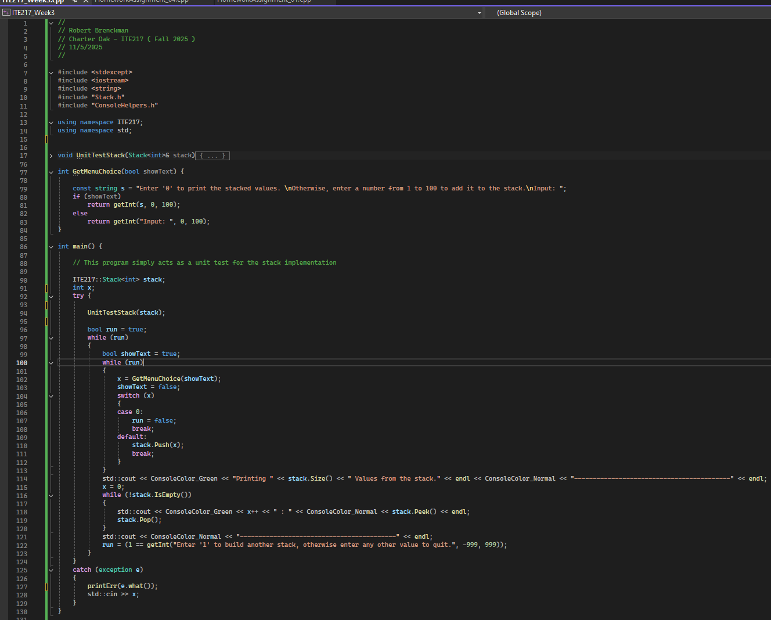
Stack.h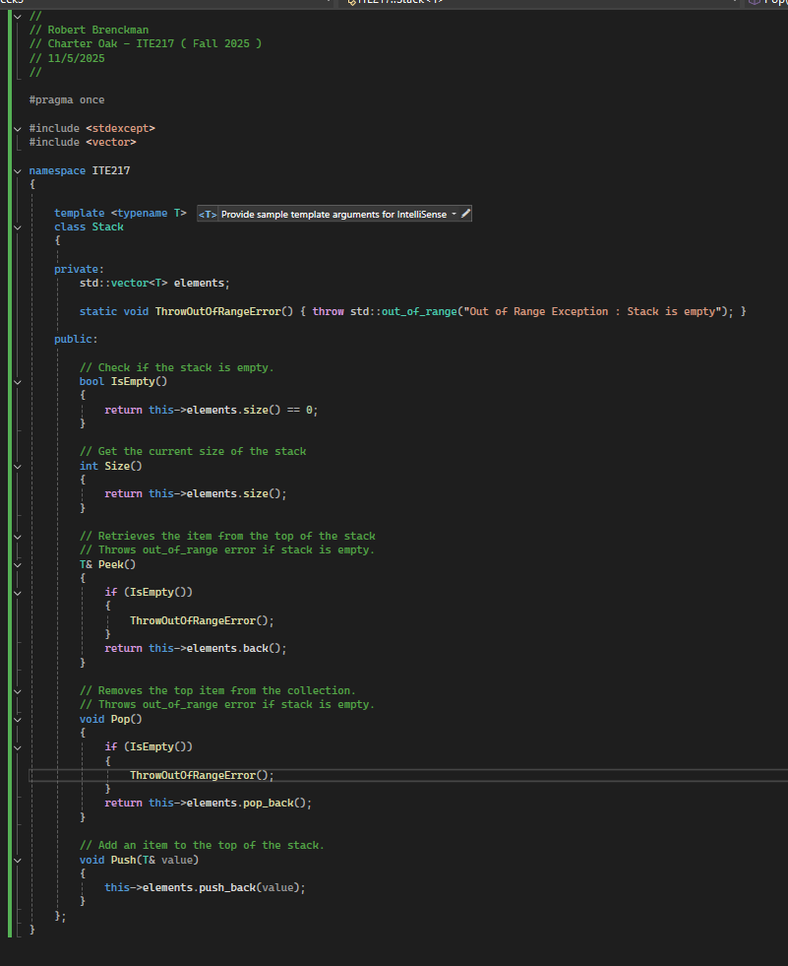

ConsoleHelpers.h & ConsoleHelpers.cpp
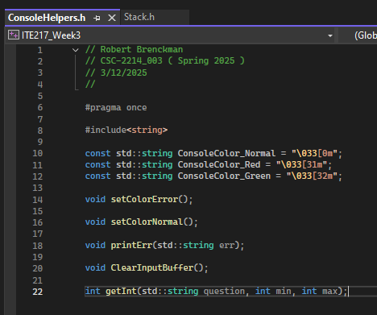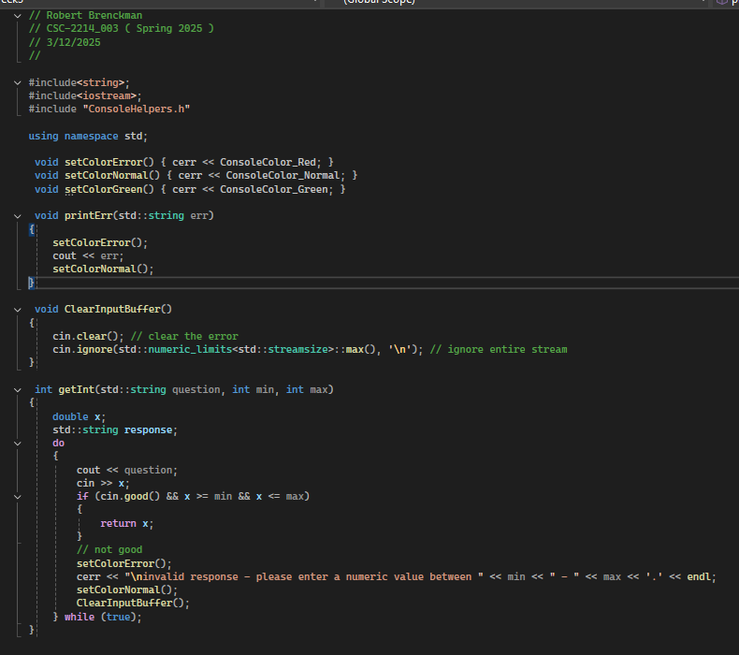

Run Screenshot
